Student Name : M Harinath
Registration Number : 192425020
Course Code & Name : MLA0302 - Reinforcement Learning
Date of Submission : 21-07-2026

PROGRAM 2: ε-Greedy Multi-Armed Bandit

Aim :
To implement the ε-Greedy Multi-Armed Bandit algorithm and compare exploration and exploitation using different ε values.

Procedure :
- Define reward probabilities for each bandit.
- Initialize reward estimates.
- Select actions using ε-Greedy strategy.
- Update estimated rewards.
- Display total rewards for ε = 0.1, 0.3, and 0.5.

Code :
import random
bandits = [0.2, 0.5, 0.8]
trials = 500
for epsilon in [0.1, 0.3, 0.5]:
values = [0, 0, 0]
counts = [0, 0, 0]
total_reward = 0
for i in range(trials):
if random.random() < epsilon:
action = random.randint(0, 2)
else:
action = values.index(max(values))
reward = 1 if random.random() < bandits[action] else 0
counts[action] += 1
values[action] += (reward - values[action]) / counts[action]
total_reward += reward
print("Epsilon =", epsilon)
print("Total Reward =", total_reward)
print()

Output :
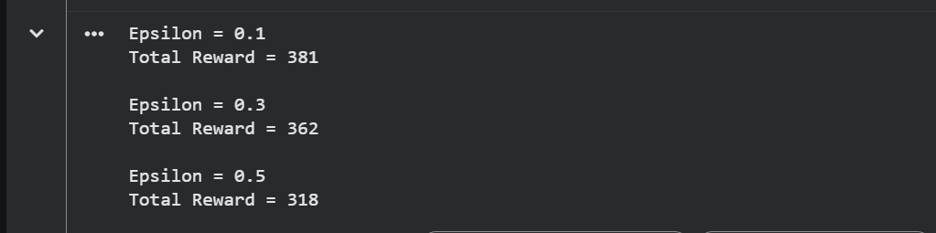

PROGRAM 8: Random vs ε-Greedy
Aim:
To compare Random Action Selection and ε-Greedy strategy.

Procedure :
- Define three bandits.
- Run random selection.
- Run ε-Greedy.
- Compare cumulative rewards.

Code :
import random
bandits = [0.2, 0.5, 0.8]
trials = 500
# Random
random_reward = 0
for i in range(trials):
arm = random.randint(0,2)
if random.random() < bandits[arm]:
random_reward += 1
# Epsilon Greedy
epsilon = 0.1
values = [0,0,0]
counts = [0,0,0]
greedy_reward = 0
for i in range(trials):
if random.random() < epsilon:
arm = random.randint(0,2)
else:
arm = values.index(max(values))
reward = 1 if random.random() < bandits[arm] else 0
counts[arm]+=1
values[arm]+= (reward-values[arm])/counts[arm]
greedy_reward+=reward
print("Random Reward =", random_reward)
print("Epsilon Greedy Reward =", greedy_reward)

Output :

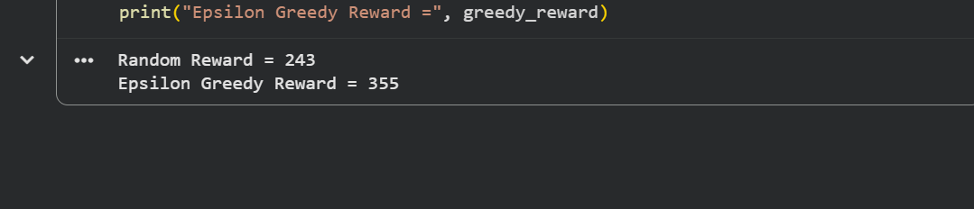

PROGRAM 5: Warehouse Robot Battery Constraint
Aim:
To design an RL framework for a warehouse robot with a battery limit of 30 minutes.

Procedure :
- Set battery capacity.
- Each delivery consumes battery.
- Give reward for every successful delivery.
- Stop when battery becomes insufficient.
Code:
battery = 30
reward = 0
deliveries = 0
while battery >= 5:
battery -= 5
reward += 10
deliveries += 1
print("Deliveries =", deliveries)
print("Remaining Battery =", battery)
print("Total Reward =", reward)

Output:

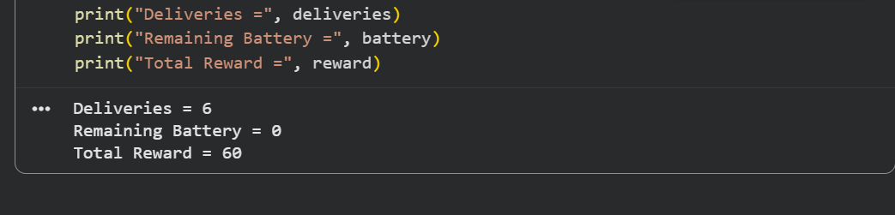

PROGRAM 4: Value Iteration (Grid World)
Aim:
To implement Value Iteration for finding the optimal policy in a grid environment.

Procedure :
- nitialize state values.
- Update values using Bellman Equation.
- Repeat until convergence.
- Print optimal values.
Code:
import numpy as np
grid = np.zeros((3,3))
reward = -1
gamma = 0.9
for iteration in range(10):
new_grid = grid.copy()
for i in range(3):
for j in range(3):
if (i,j)==(2,2):
continue
values=[]
if i>0:
values.append(grid[i-1][j])
if i<2:
values.append(grid[i+1][j])
if j>0:
values.append(grid[i][j-1])
if j<2:
values.append(grid[i][j+1])
new_grid[i][j]=reward+gamma*max(values)
grid=new_grid
print(grid)

Output :

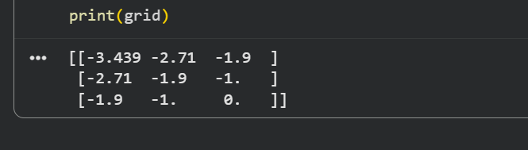

PROGRAM 10: Smart Energy Management
Aim:
To implement an RL-based smart energy management system with an electricity usage limit.

Procedure :
- Set energy threshold.
- Monitor energy usage.
- Give reward if usage stays below threshold.
- Otherwise apply penalty

Code :
energy_used = [12, 15, 10, 18, 8]
threshold = 15
reward = 0
for e in energy_used:
if e <= threshold:
reward += 10
print("Energy:", e, "Reward +10")
else:
reward -= 5
print("Energy:", e, "Penalty -5")
print("Total Reward =", reward)

Output :

